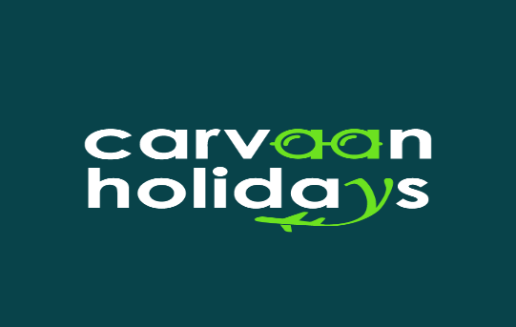 | CARVAAN HOLIDAYS  SHOP NO. G -3 PLOT NO. 12, HDB ARCADE DURSANCHAR NAGAR, SHAHPURA BHOPAL - 462026  Email: info@carvaanholidays.com – Phone: +91 9131978160  Website: https://www.carvaanholidays.com

Ref. Query ID: CH13111204 | Date: 13 Nov 2025
EUROPE (11N/12D)

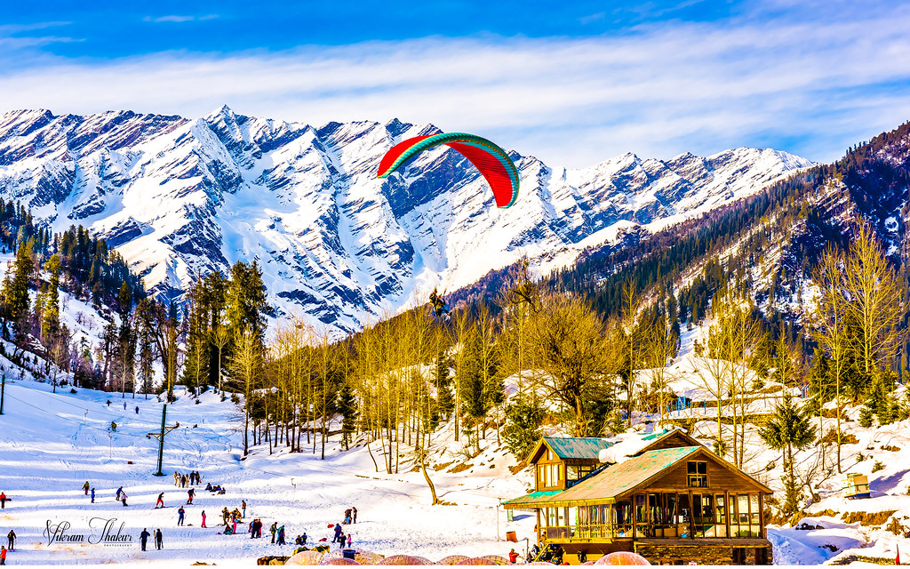

QUOTE DETAILS
Visit Places | Rome (2N) - Florence (3N) – Venice – Salgburg – Vienna – Budapest – Prague – Frankfurt
Travel Date | 12 April 2026 | Total Days | 12
Total Passenger | 2 Adult(s) | Quote Include | Hotels, Vehicles

SHORT ITINERARY

- DAY 1: ARRIVAL ROME
- Day 2 : ROME TOUR
- Day 3 : ROME - FLORENCE
- Day 4 : FLORENCE - VENICE
- Day 5 : VENICE – INNSBRUCK – SALGBURG
- DAY 6 : SALZBURG – LAKE TRAUNSEE – VIENNA
- DAY 7 : VIENNA
- DAY 8 : VIENNA – BUDAPEST
- DAY 9 : BUDAPEST - BRATISLAVA – PRAGUE
- DAY 10 : PRAGUE
- DAY 11 : PRAGUE – PILSEN – ROTHENBURG – FRANKFURT
- DAY 12 : FRANKFURT DEPARTURE

VEHICLE DETAILS:
Vehicle | Pick-Up | Drop
Bus | Rome | Frankfurt

HOTEL DETAILS:
PACKAGE COSTING & HOTELS | TOTAL TOUR COST  For Couple
SPR. DELUXE  ROME - ERGIFE  FLORENCE - NILHOTE  VENICE - NOVOTEL MESTRE CASTELLANA  SALBURG - IBIS SALZBURG NORD  VIENNA - RAINERS HOTEL VIENNA  BUDAPEST - DANUBIUS ARENA  PRAGUE - PANORAMA HOTEL PRAGUE  PRAGUE - OLYMPIK CONGRESS  FRANKFURT - IBIS FRANKFURT CITY MESSE | INR 40,600/-

|| DETAILED ITINERARY||

ROME 3ºC - 5ºC
Welcome to Rome! Upon your arrival, we’ll be there to transfer you to your hotel. Later, our guide will meet you and provide all the essential information. You can also find details on the information sign in the hotel reception area.
In the evening, we’ll take you to Via Cavour, an excellent introduction to Rome. Here, you’ll find a variety of restaurants offering Italian, Indian, Chinese, and international cuisine.
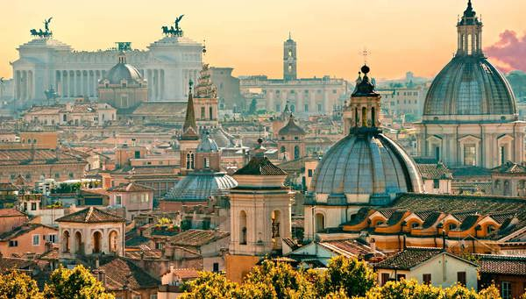
Day 2 - MON.
ROME 3ºC - 5ºC
In the morning, we’ll take a three-hour guided tour of the Eternal City, combining a walking tour through Imperial Rome with a panoramic bus ride to admire one of the oldest and most influential cities in Western civilization. During the tour, we’ll see iconic landmarks such as the Arch of Constantine, the exterior of the Colosseum and the Imperial Forums, the Circus Maximus, the Baths of Caracalla, the Basilica of Saint Mary Major, the Pyramid of Cestius, and Castel Sant’Angelo.
The tour will end at VATICAN CITY around 11:00 a.m. Afterward, our guide will offer an optional visit to explore the Vatican Museums and the Sistine Chapel.
At the end of the day, we’ll include a transfer to the popular Trastevere neighborhood, known for its cozy restaurants and lively atmosphere. Return to the hotel will be around 8:30 p.m.
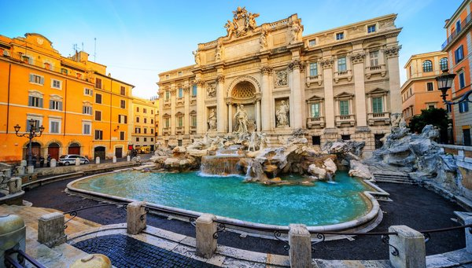
Day 3 - TUE.
ROME 3ºC - 5ºC - FLORENCE 16ºC - 18ºC
Today, we’ll leave Rome and head north, taking in the beautiful landscapes along the way. Upon reaching Florence, we’ll go directly to the stunning Piazzale Michelangelo for breathtaking views of the city. We will then walk toward the historic center where, after some time for lunch, we’ll enjoy a guided walking tour with a local expert through the historic center, visiting landmarks such as the Ponte Vecchio, the Duomo, and Piazza della Signoria. This city is like an open-air museum.
Afterward, you´ll have some free time to explore at your leisure. In the evening, you’ll have plenty of options for dinner, as this district offers many restaurants with a variety of international cuisines.
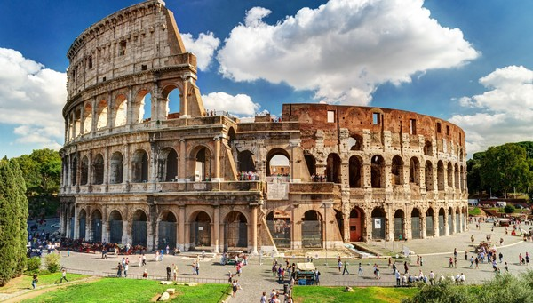
Day 4 - WED.
FLORENCE 16ºC - 18ºC - VENICE 17ºC - 18ºC
Today, we’ll enjoy the stunning mountain landscapes as we cross the Apennines. Upon arriving in Venice, we’ll take a boat across the Giudecca Canal to the Island of Venice. With a local guide, we’ll visit the marvelous St. Mark’s Square. Afterwards, we’ll tour the Murano Glass Factory, where you’ll see the fascinating techniques used to create this ancient glass. You´ll have some free time to explore on your own. Accommodation will be in the Mestre district.
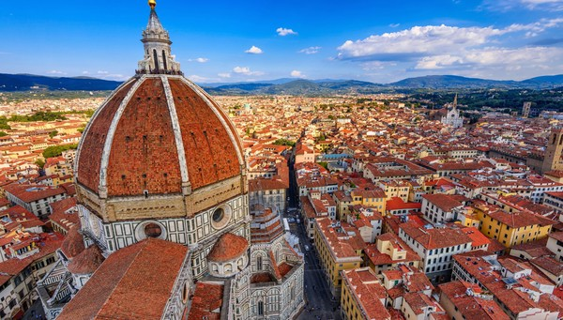
Day 5 - THU.
VENICE 17ºC - 18ºC - INNSBRUCK 11ºC - 17ºC - SALZBURG 13ºC - 13ºC
We will depart from Venice, traveling to AUSTRIA! Upon arriving in INNSBRUCK, you’ll have time to stroll through the historic city center and enjoy lunch in the Austrian Tyrolean capital. Afterward, we’ll journey along beautiful scenic roads through the mountains to KITZBÜHEL. Once there, you’ll have time to explore this picturesque village, a famous ski resort where snow can be enjoyed for most of the year. We’ll continue our journey to SALZBURG, arriving by the end of the day.
Note: If there are few travelers, we may take a train from Venice to Innsbruck.
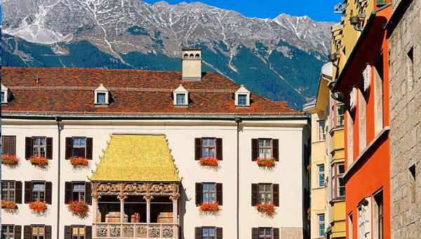
Day 6 - FRI.
SALZBURG 13ºC - 13ºC - LAKE TRAUNSEE - VIENNA 3ºC - 7ºC
Today, we’ll get to know AUSTRIA better. During the morning, we´ll explore SALZBURG, Mozart’s city. Its Renaissance and Baroque center is filled with beauty, all in the shadow of the grand castle. Next, we’ll travel through lakes and mountains to reach ST. WOLFGANG, a renowned pilgrimage site in Austria. We’ll then head to TRAUNKIRCHEN, located beside the beautiful Traunsee Lake, where we’ll take an included cruise to see four of the lake´s castles before disembarking in GMUNDEN. Afterward, we’ll continue to VIENNA, arriving in the evening.
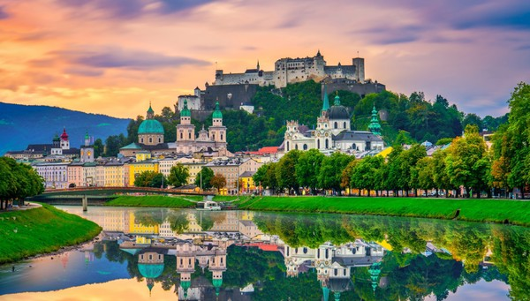
Day 7 - SAT.
VIENNA 3ºC - 7ºC
Today, we’ll embark on a panoramic tour of this impressive city with a local guide. We’ll explore its majestic avenues, beautiful palaces, large parks and vibrant city center. In the afternoon, you’ll have free time to explore on your own. In the evening, we’ll include a transfer to the Grinzing district, an old wine-growing village now part of the city, known for its traditional taverns. You’ll have free time to dine in the area.
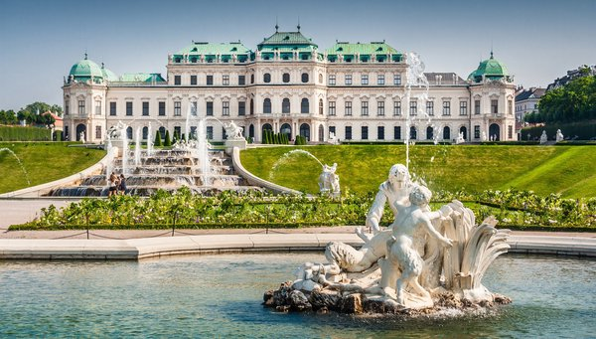
Day 8 - SUN.
VIENNA 3ºC - 7ºC - BUDAPEST 6ºC - 7ºC
After about three hours of travel, we’ll arrive in BUDAPEST, the capital of HUNGARY. Our first stop will be the lively area of Váci utca, where you’ll have free time for lunch. After, we’ll kick off our exploration of Budapest with an included boat trip on the Danube River, with historic Buda on one bank and cosmopolitan Pest on the other. The views are unbeatable. Following this, we’ll begin a panoramic tour of the so-called "Queen of the Danube." You’ll have some free time afterwards. In the evening, we’ll offer an optional outing to a Magyar show, with dinner included.
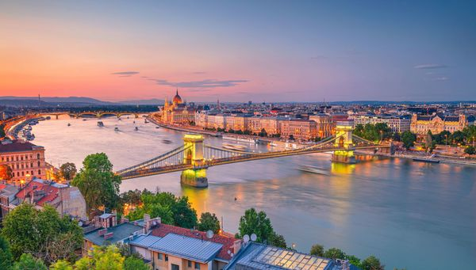
Day 9 - MON.
BUDAPEST 6ºC - 7ºC - BRATISLAVA 5ºC - 7ºC - PRAGUE 5ºC - 12ºC
We will leave BUDAPEST early and head for BRATISLAVA, the capital of SLOVAKIA, a charming city along the Danube with an attractive historic center. You´ll have time to explore and enjoy lunch. After, we’ll continue our journey to the CZECH REPUBLIC, arriving in PRAGUE in the evening. We’ll provide a transfer to the Old Town Square, a central spot that offers a fantastic introduction to Prague with its vibrant atmosphere and numerous tourist activities. You can have dinner at one of the many restaurants offering a variety of international cuisines, including Czech, Chinese, Indian, and Italian. Afterward, we’ll return to the hotel.
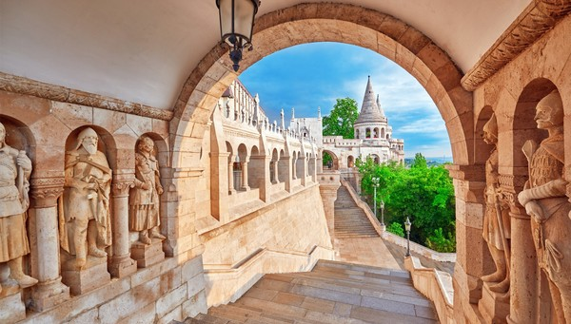
Day 10 - TUE.
PRAGUE 5ºC - 12ºC
Today, we’ll visit the capital, PRAGUE, the Baroque jewel of Europe. Our local tour guide will lead an informative panoramic tour, highlighting the city’s most outstanding monuments. During the tour, there will be a visit to Prague Castle (admission included). After that, enjoy a boat ride on the Vltava River (included). In the afternoon, you’ll have free time to explore the city on your own.
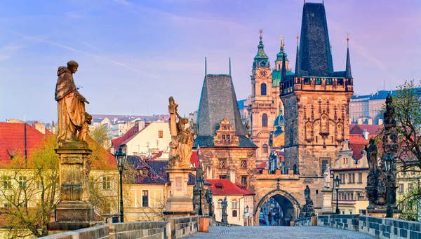
Day 11 - WED.
PRAGUE 5ºC - 12ºC - PILSEN 11ºC - 11ºC - ROTHENBURG 9ºC - 10ºC - FRANKFURT 11ºC - 14ºC
We’ll depart early from Prague and stop in Pilsen, in western Bohemia, a city renowned for its beer. You’ll have time to stroll through its historic center, where you’ll find the Old Town Square, the cathedral, the Plague Column, and a Renaissance-era town hall. We’ll then cross into Germany and follow part of the Romantic Road. We’ll visit Rothenburg, a town that seems to come straight out of a fairy tale and is considered one of the most beautiful villages in the country. Afterward, we’ll head to Frankfurt, the financial capital of Germany. After our arrival in the evening, enjoy free time in the historic city center, where you’ll find a wide variety of restaurants offering Indian, Asian, Italian, and international cuisines.
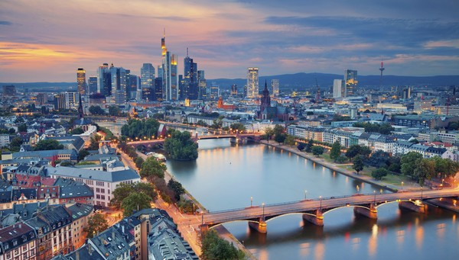
Day 12 - THU.
FRANKFURT 11ºC - 14ºC
After breakfast, our journey will come to an end, leaving you with wonderful lasting memories.
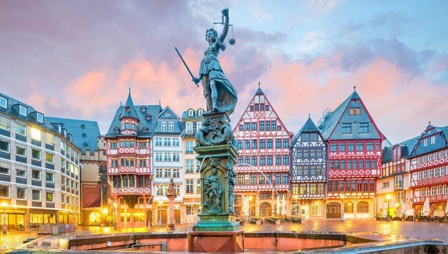

ETAILED ITINERARY|||| DETAILED ITINERARY|
END OF TOUR WITH MEMORABLE MOMENTS

BEFORE BOOKING, PLEASE READ THE BELOW CAREFULLY

SPECIAL INCLUSIONS:
- Europamundo General Services: Travel by bus with English speaking guide, basic travel insurance, hotel and breakfast buffet.
- Includes arrival transfer
- City tour in: Rome, Florence, Venice, Vienna, Budapest, Prague
- Boat: to the island of Venice, Traunsee Lake in Traunkirchen , Danube River in Budapest , Vltava River in Prague
- Evening transfer: Via Cavour in Rome, Trastevere in Rome , Grinzing district in Vienna , Old Town Square in Prague
- Transfer: Piazzale Michelangelo in Florence
- Ticket admission: Murano Glass Factory in Venice, Prague Castle

TOUR EXCLUSION:

- Flights, Trains, Ferries etc.
- Personal Expenses - Laundry, Shopping, Telephone bills, tips etc.
- Anything else not listed in above details

PAYMENT POLICY:
50% of the total amount should be paid at the time of booking and the balance amount to be paid on or before 10 days of travel date.

BANK DETAILS:

ACCOUNT Name - Carvaan Holidays
Account No. - 327105500026
IFSC Code - ICIC0003271
Account Type - Current

HOTEL/LAND CANCELLATION POLICY
- Date of booking to 30 days before travel the cancellation charges will be 25% of the tour cost (During Season) & Nill (During Off-Season)
- 30 to 15 days before the trip - cancellation charges will be 50% of the tour cost (During Season) & 25% (During Off-Season)
- 15 to 7 days before travel - cancellation charges will be 75% of the tour cost (During Season) & 50% (During Off-Season)
- 0 to 7 days before travel - cancellation charges will be 100% of the tour cost. No refund shall be given
- Please Note: Cancellation policy is subject to change. It depends on the hotel policy.
- In peak season (example: long weekends, festival season, summer vacation, etc.) most of the hotels charge 100% cancellation.
For more information about cancellation policies, please contact our sales/reservation executive.

Note: our programs are 100% personalized, and for this reason, we do not consider this first proposal as definitive. We can adapt and modify your trip to your desires and your budget. There are cheaper and more expensive hotels equivalent to different levels of comfort.
I remain here at your disposal for any further information; please contact us by e-mail, telephone.
I would be happy to respond.

